‘The Forkers’ Team

Submitted on March 24, 2019

Project proposal for

**ForkYou** Web Application

Course FS1010

Team members:

Daniel Gonzalez

Samarjit Mann

Wilson Fong

Sebastien Beaury

A. Introduction – Project Scenario 3

B. Needs/Problems 4

C. Goals/Objectives 4

D. Procedures/Scope of Work 4

E. Timetable 5

F. Personas 6

G. Wireframe 7

# Introduction – Project Scenario

The main purpose of the proposed web application is to provide a food plan to ~16 to 65 years old web users based on a request made of preferred ingredients. The app will also provide some additional features like displaying healthy meals only. It will be a single page application built on ReactJS and Bootstrap UI.

# Needs/Problems

The targeted audience will be for those who seek recipe ideas and with healthy meal option based on the ingredients available as well as anyone looking for tips when cooking for someone.

# Goals/Objectives

The app should display:

* Information about each recipe
* Nutritional metrics such as number of calories
* Short description of the recipe
* Picture of the meal
* Link to the full recipe

# Procedures/Scope of Work

The app will be built using a ReactJS architecture and a Bootstrap framework. The API that will be consumed is Spoonacular **[1]**.

The development team will follow the following steps:

* user stories
* wireframing
* draft MVP
* development
* testing

# Timetable

|  |  |  |
| --- | --- | --- |
|  | Description of Work | Start and End Dates |
| Phase 1 | Planning & Design (Wireframes) | March 17 – March 24 |
| Phase 2 | Backend & API calls | March 25 – April 7 |
| Phase 3 | Front End & UI | April 8 – April 20 |
| Phase 3 | Validate MVP - User Test | April 21 – April 27 |

# Personas

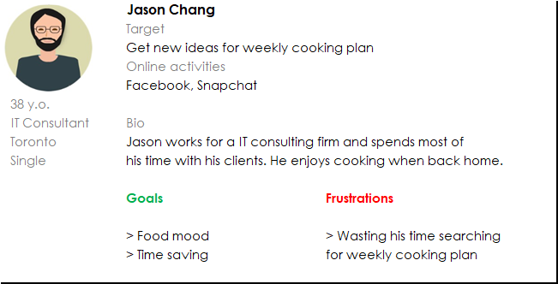

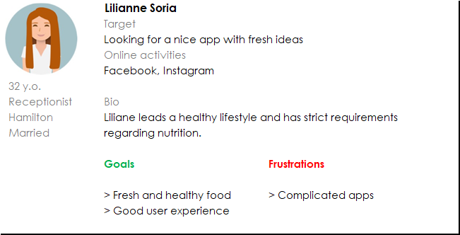

# Wireframe

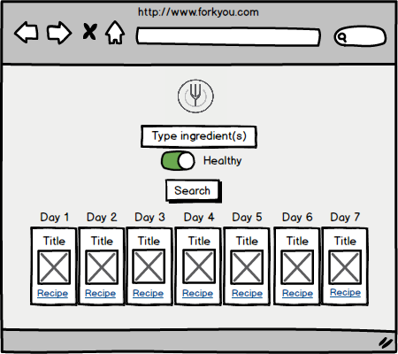

1. “Food API and Recipe API.” *Spoonacular*, https://spoonacular.com/food-api.